Running wire to the SEM7830 box

Note: this is from Paul’s notes – Sentronic-> Eastek Trivolt Magnets -> 7830SEM Install drawing

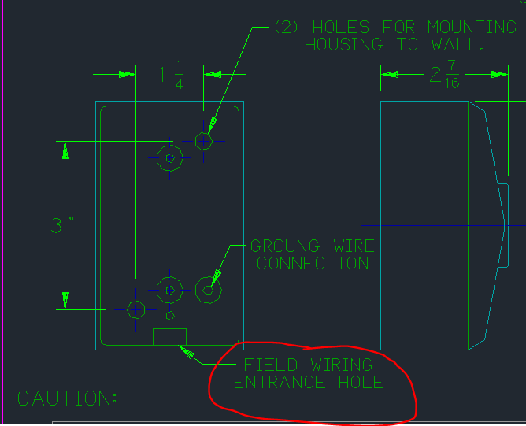

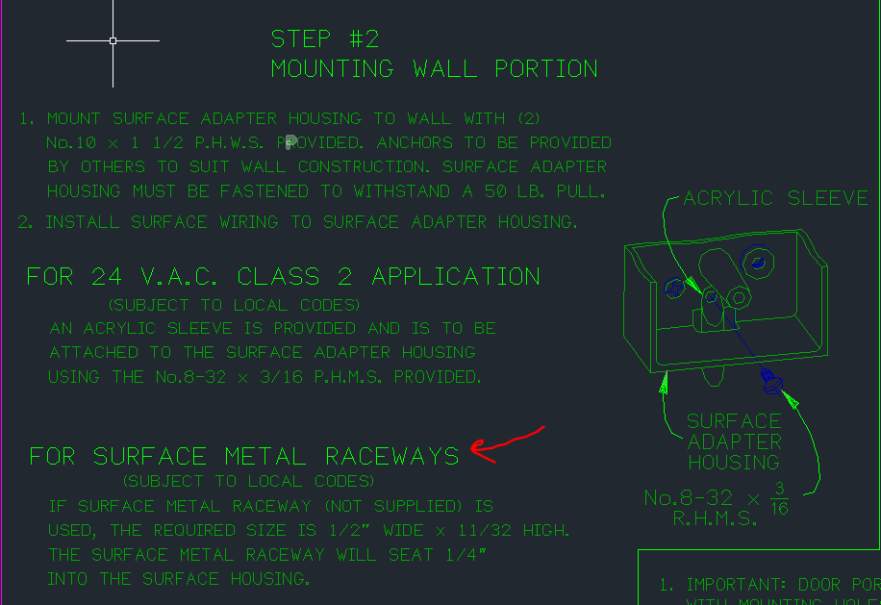

Surface Metal Raceways are called Wiremold in laymens terms. This is used to run wires in many applications, such as in schools.

Here’s a link John Weiss sent me as an example:

<https://www.homedepot.com/p/Legrand-Wiremold-500-Series-10-ft-Metal-Surface-Raceway-Channel-in-Ivory-V500/100207385>