New spring cage for dummy functions
The new spring cage is used with ALX and ND both the 170 & 172 dummy functions.
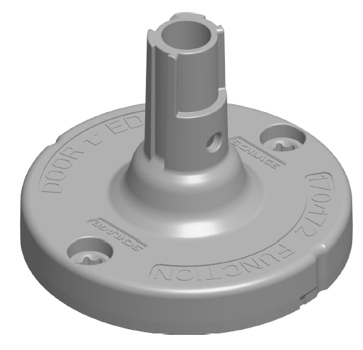
-Single cast part.
- will surface mount. (Through bolt is optional.)

Old spring cage for dummy functions
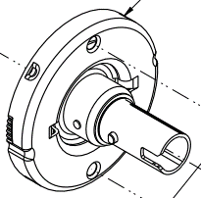

-Assembled machined parts. (Requires through bolt)

